PHASE 3: Project Design Phase
Project Team Members
M.G Misriyathul Ibrahima
S.M.B.N Meera Jenira
V.Mohana
P.Mutharasi
S.A.K. Muthu Ameena

Project: Implement Client Script & UI Policy (Incident)
ServiceNow – Incident Management

Phase Objective
To design how the ServiceNow components would interact to enforce the required Incident business rules.

UI Policy Design
A UI Policy named High Impact Control was designed for the Incident table. The condition is Impact = 1 – High, and Reverse if false is enabled so that policy effects are reversed when the condition is no longer true.

UI Policy Action Design
The Urgency field is controlled through a UI Policy Action. When the policy condition is satisfied, Urgency is configured as read-only.

Client Script Design
- onChange Client Script: watches Impact and sets Urgency to High when Impact becomes 1.
- onSubmit Client Script: checks High Impact + empty Assigned To and prevents saving with an error message.
- onCellEdit Client Script: blocks direct State changes from an Incident list and asks the user to open the Incident form.

Logical Flow
Impact = High → UI Policy becomes active → Assigned To is required and Urgency is controlled → onChange sets Urgency to High → onSubmit validates Assigned To before save.

Reverse Flow
Impact changed away from High → Reverse if false restores the policy-controlled field behavior to its normal state.

Project Evidence – Screenshots
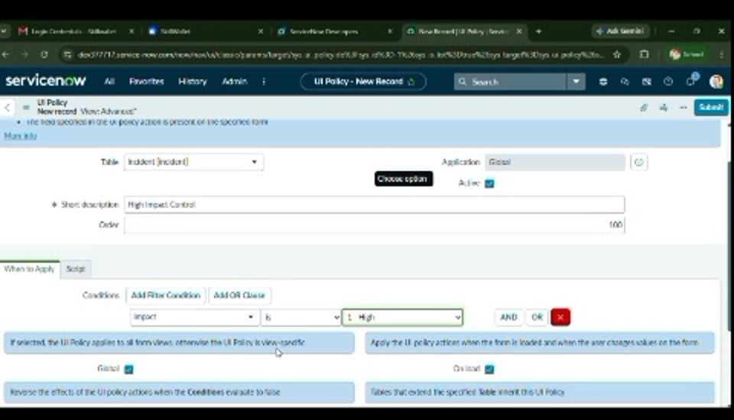
Figure 4. Designed UI Policy condition for High Impact.
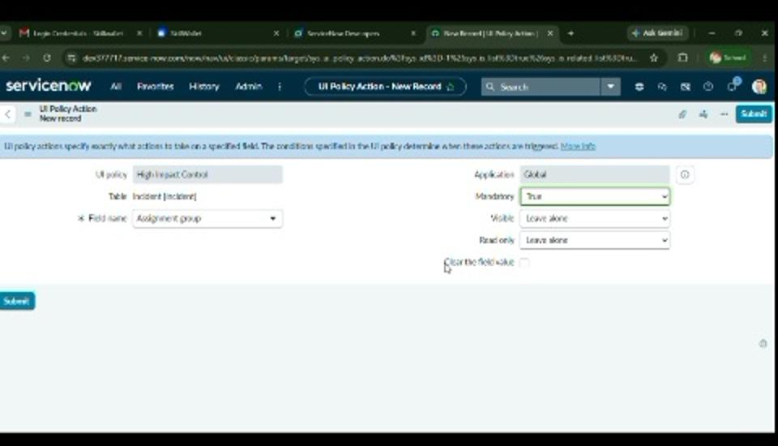
Figure 5. UI Policy Action showing the controlled Incident field configuration.

Phase Outcome
A clear design was prepared for the High Impact Control UI Policy, Urgency UI Policy Action, and the onChange, onSubmit, and onCellEdit Client Scripts.

